RESEARCH PROJECT PROPOSAL
PACER
Prediction-Aware Context-Efficient Retrieval
with Adaptive Compression and Cache Reuse
A literature-grounded proposal for low-latency Retrieval-Augmented Generation on local, open-source LLMs

Revised scientific framing — October 2026
Prepared from the supplied research-gap analysis, proposal draft, and cross-checked published/arXiv literature.

IMPORTANT POSITIONING NOTE
This proposal does NOT claim predictive prefetching, adaptive compression, or KV-cache reuse as individually novel. The scientific novelty is the coordination policy, the controlled causal ablations, and the resource-constrained evaluation question.

Executive research decision
The earlier proposal contained several claims that became too strong once the newest 2026 papers were considered. In particular, single-GPU validation is no longer absent: TeleRAG provides an RTX 4090 evaluation with Llama-3.2-3B and Llama-3-8B, and the KV-cache literature now includes CacheTune, FusionRAG and CoinRAG. The revised proposal therefore avoids novelty-by-absence.
The recommended research problem is narrower and stronger: determine whether a prediction-conditioned controller can jointly decide (i) whether/when retrieval should be initiated and (ii) how much retrieved evidence should be retained/compressed under a latency budget, and determine whether that coordination produces a statistically reliable improvement over matched single-technique systems on a single GPU.
- High feasibility: the individual components have public implementations/papers and can be evaluated with small open-source models.
- Moderate novelty risk: simple chaining of existing methods is not sufficient; the controller must create a measurable interaction or new operating policy.
- Core claim should be empirical and falsifiable: coordination may improve, match, or lose to the best single technique.
- KV-cache reuse should be treated as a second-stage extension after the prediction+compression study is stable.
- Multimodal retrieval is an extension track, not evidence for the core text-RAG novelty.
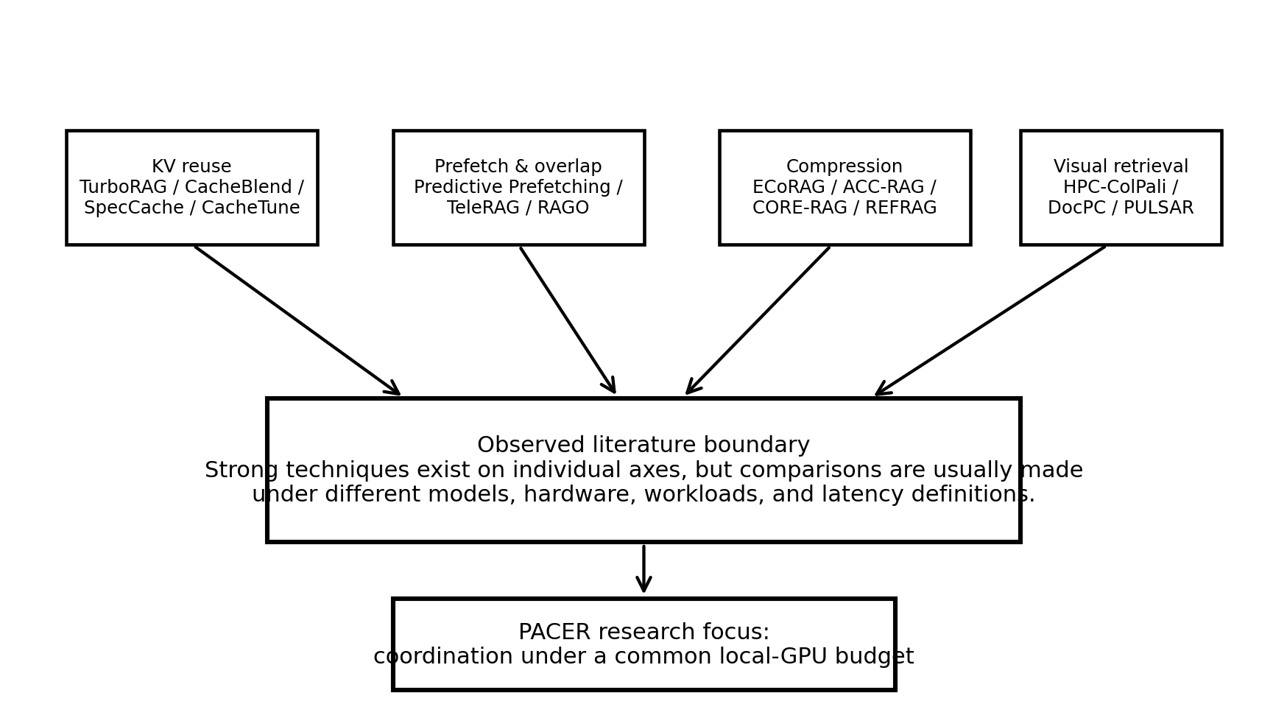
Figure 1. Reframed literature landscape and the narrower research focus.

1. Title of the proposed model
PACER — Prediction-Aware Context-Efficient Retrieval with Adaptive Compression and Cache Reuse.
Short scientific description: a lightweight runtime controller for local RAG that uses a retrieval-need/timing signal, evidence utility, and an explicit latency budget to decide when to retrieve, how much evidence to retain, and—at the later stage—when cached representations are worth reusing.

2. Introduction
Retrieval-Augmented Generation reduces the dependence of language models on parametric memory by supplying external evidence at inference time. The same mechanism creates a systems problem: retrieved passages lengthen the prefill sequence, retrieval may block generation, and repeated contexts create opportunities for KV-cache reuse. Recent work has attacked these costs through several strong but specialized directions: RAGCache and later systems reuse KV states; CacheBlend, SpecCache, CacheTune and FusionRAG reduce recomputation; Predictive Prefetching and TeleRAG overlap or anticipate retrieval; ECoRAG, ACC-RAG, CORE-RAG and REFRAG reduce context or alter how context is consumed.
The literature review supplied with this proposal is valuable because it exposes a recurring structural issue: latency results are difficult to compare because papers change the model, hardware, cache hierarchy, retrieval backend, workload, and metric simultaneously. The review also identifies adaptive resource allocation as a repeated open direction. However, newer 2026 papers mean that the proposal must not claim that single-GPU RAG latency or prediction-plus-systems combinations are completely unexplored.
The research therefore moves from a broad 'combine three techniques' claim to a scientific control problem: given a fixed local compute budget, can a controller allocate retrieval and evidence tokens according to predicted information need and expected latency benefit more effectively than independent policies?

3. Problem statement
A conventional RAG request pays for retrieval, context processing, and generation even when some retrieved evidence is unnecessary or when the retrieval can be overlapped with computation. Compression reduces context length but introduces its own scoring/selection cost. Prefetching reduces visible retrieval delay but can waste resources when predictions are wrong. Caching can avoid repeated prefill but may require storage, transfer, and cross-context correction.
The central problem is therefore not whether each optimization works independently. It is whether their decisions should be coordinated. The proposed system treats retrieval triggering and evidence budgeting as coupled decisions under a common latency-quality objective.
A useful decomposition is:
- T_total = T_predict + T_retrieve + T_compress + T_prefill + T_decode + T_transfer/overlap effects.
- A technique is useful only when the latency removed is larger than the latency and memory cost it introduces.
- A false-positive prefetch is not a gain; it is a resource expenditure that must appear in the measured end-to-end result.
- Compression ratio alone is not an objective; retained evidence must preserve answer quality.
- Cache hit rate alone is not an objective; cache loading and selective recomputation must be included.

4. Short literature review of research papers
The literature is organized below by mechanism rather than by publication date. The 'what is established' column records the contribution that should be treated as prior art; the 'remaining opening' column is deliberately conservative and avoids claiming that no related paper exists.
Paper / venue | Core mechanism | Established result | Conservative remaining opening | Ref.
RAGCache (2024) | Hierarchical KV caching, prefix-aware organization, cache-aware scheduling and retrieval/inference overlap. | Establishes that repeated retrieved knowledge can be cached and that cache hierarchy matters. | Order sensitivity and workload-dependent cache reuse remain important constraints. | [1]
TurboRAG (EMNLP 2025) | Offline chunk KV precomputation with stitched-cache inference and model adaptation. | Shows very large TTFT reductions are possible by moving computation offline. | Fine-tuning cost and dynamic-corpus/model-update coupling limit local reproducibility. | [2]
CacheBlend (EuroSys 2025) | Selective KV recomputation to recover cross-chunk effects. | Establishes non-prefix cache fusion with selective recomputation. | Selection policy and hardware/storage trade-offs remain open for matched local comparisons. | [3]
SpecCache (ACL 2026) | Speculative-model proxy for identifying KV tokens that need recomputation. | Establishes predictive/selective KV reuse as a strong alternative to fixed heuristics. | Extra model overhead and broader local-budget comparisons remain relevant. | [4]
CacheTune (arXiv 2026) | Frequency-guided selective recomputation plus hardware-aware adaptive ratio tuning. | Establishes that cache reuse and I/O/compute scheduling can be co-optimized. | Does not solve joint retrieval-need + evidence-budget control. | [5]
FusionRAG (SIGMOD 2026) | Offline cross-chunk context fusion plus query-guided selective recomputation. | Strengthens quality/efficiency trade-off for KV reuse. | Offline preprocessing cost and freshness remain practical constraints. | [6]
PCR (arXiv 2026) | Prefix-tree cache, look-ahead LRU, pipelined transfers and queue prefetching. | Establishes infrastructure-level cache prefetch and storage overlap. | Exact-prefix dependence remains distinct from semantic selective reuse. | [7]
CoinRAG (arXiv 2026) | Fine-grained information-nugget KV reuse under low prefill latency budgets. | Establishes that chunk-level reuse can be refined to smaller semantic units. | Model-specific adaptation and nugget/context construction remain costs. | [8]
Predictive Prefetching (ICML 2026) | Learned prediction of retrieval timing and query generation from generation dynamics. | Establishes learned retrieval-need/timing prediction. | False-positive cost and integration with adaptive evidence budgets remain open. | [9]
TeleRAG (MLSys 2026) | Lookahead retrieval and GPU-memory-aware retrieval/inference overlap. | Establishes practical single-GPU lookahead evaluation and a systems-level implementation. | Does not answer how much evidence should be retained after retrieval. | [10]
HedraRAG (arXiv 2025) | Graph-based heterogeneous scheduling across RAG stages and concurrent requests. | Establishes workload-aware systems scheduling. | Primary focus is heterogeneous/concurrent serving rather than a local single-request controller. | [11]
RAGO (arXiv 2025) | RAGSchema workload characterization and optimizer for serving. | Establishes that optimal systems behavior depends strongly on workload structure. | Resource-constrained local inference is a different operating regime. | [12]
VoiceAgentRAG (arXiv 2026) | Background prediction and semantic caching for conversational retrieval. | Establishes predictive background retrieval and explicitly discusses generation-dominated latency. | Domain is voice/multi-turn; local text-QA control is not its primary experiment. | [13]
REFRAG (arXiv 2025) | Embedding-based context compression and selective expansion. | Establishes architectural context compression can radically reduce TTFT. | Training/alignment cost is substantial for direct reproduction on a small local budget. | [14]
ECoRAG (ACL Findings 2025) | Evidence/evidentiality-guided context compression with retrieval reflection. | Establishes evidence-aware compression and quality-sensitive retrieval/compression feedback. | Its evidence controller is not coupled to a learned retrieval timing controller. | [15]
ACC-RAG (EMNLP Findings 2025) | Adaptive compression rate conditioned on input complexity. | Establishes query-adaptive compression rather than a single fixed ratio. | Controller overhead and joint latency optimization remain open. | [16]
CORE-RAG (ICML 2026) | Performance-driven compression learned from task feedback. | Establishes that compression can be optimized against downstream task performance. | Reward cost and integration with runtime retrieval timing remain open. | [17]
HPC-ColPali (arXiv 2025) | Patch quantization and attention-guided pruning for visual document retrieval. | Establishes a visual-retrieval compression direction. | The supplied review notes its numerical results are design estimates; it is not a core text-RAG baseline. | [18]
DocPC (arXiv 2026) | Representative-page composition for document-level visual retrieval. | Establishes page-count reduction for visual document indexing. | Fixed representative-page selection leaves room for query-adaptive budgeting. | [19]
PULSAR (arXiv 2026) | Pooling/quantization and two-stage visual retrieval. | Establishes large retrieval-index efficiency gains in a production visual-document setting. | Generalization and combination with adaptive page/patch selection remain open. | [20]

The table deliberately separates established prior art from the proposed research question. A paper being 'adjacent' is not treated as evidence that the proposed idea is automatically novel.

5. Research question
Primary research question (recommended):
RQ1 — Can prediction-conditioned adaptive evidence budgeting reduce end-to-end RAG latency and unnecessary retrieval/compression work, at non-inferior answer quality, compared with predictive retrieval alone, adaptive compression alone, and standard RAG on a single consumer GPU?
Secondary questions:
- RQ2 — Does the controller learn a stable relationship between predicted retrieval need, evidence utility, and an explicit latency budget across datasets?
- RQ3 — When cache reuse is added, does storing/reusing the compressed representation improve the latency–quality frontier beyond compression-only and cache-only systems?
- RQ4 — Which workload conditions (query complexity, evidence count, context length, retrieval latency) determine when coordination helps or hurts?

6. Research objectives
- Construct a matched single-GPU benchmark harness with identical retriever, model, corpus, prompt, generation settings, and latency instrumentation across all systems.
- Reproduce at least one strong baseline from each relevant axis: predictive retrieval (Predictive Prefetching or TeleRAG), adaptive compression (ECoRAG or ACC-RAG), and KV reuse (CacheBlend or SpecCache/CacheTune where feasible).
- Train or calibrate a lightweight retrieval-need/timing predictor using only signals available from the local open model.
- Build an adaptive evidence-budget controller that maps prediction confidence, evidence utility and a latency budget to a retained-token/chunk budget.
- Measure the controller's net benefit, including prediction, retrieval, compression, prefill, transfer and decode costs.
- Add compressed-context cache reuse only after the core prediction+compression experiment is stable.
- Establish confidence intervals, paired significance tests, effect sizes and latency–quality Pareto frontiers.

7. What is already established (not claimed as novel here)
- Retrieval can be overlapped with generation and can be predicted ahead of time [9,10].
- Retrieved-context KV states can be reused and selectively recomputed [1–8].
- Retrieved context can be compressed with evidence-aware or task-aware methods [14–17].
- Single-GPU RAG latency experiments are already possible and are not themselves novel; TeleRAG's public artifact explicitly includes RTX 4090 experiments with Llama-3.2-3B and Llama-3-8B [10].
- Large speedups reported in individual papers are not directly comparable across papers because the experimental stacks differ.
- Visual document retrieval has its own rapidly developing compression/indexing literature [18–20] and should not be conflated with text-RAG latency evidence.

8. What is specifically new in this proposal
The proposal's new element is not a new retriever, compressor, KV algorithm, or speculative predictor. It is a controlled coordination mechanism that treats retrieval triggering and evidence budgeting as two decisions made under one measurable latency budget.
- Prediction-conditioned evidence budgeting: retrieval-need confidence becomes an input to the compression budget instead of a separate module output.
- Net-benefit gating: a retrieval/compression action is taken only when predicted latency savings are expected to justify controller and compression overhead.
- Matched causal ablation: the same hardware, model, corpus, retriever, prompt and generation configuration are held constant while individual decisions are turned on/off.
- Workload-conditioned analysis: the system explicitly records when coordination is beneficial, neutral, or harmful rather than reporting only an aggregate speedup.
- Optional compressed-cache extension: cached representations are evaluated only after the controller is validated, avoiding a three-module black-box claim.
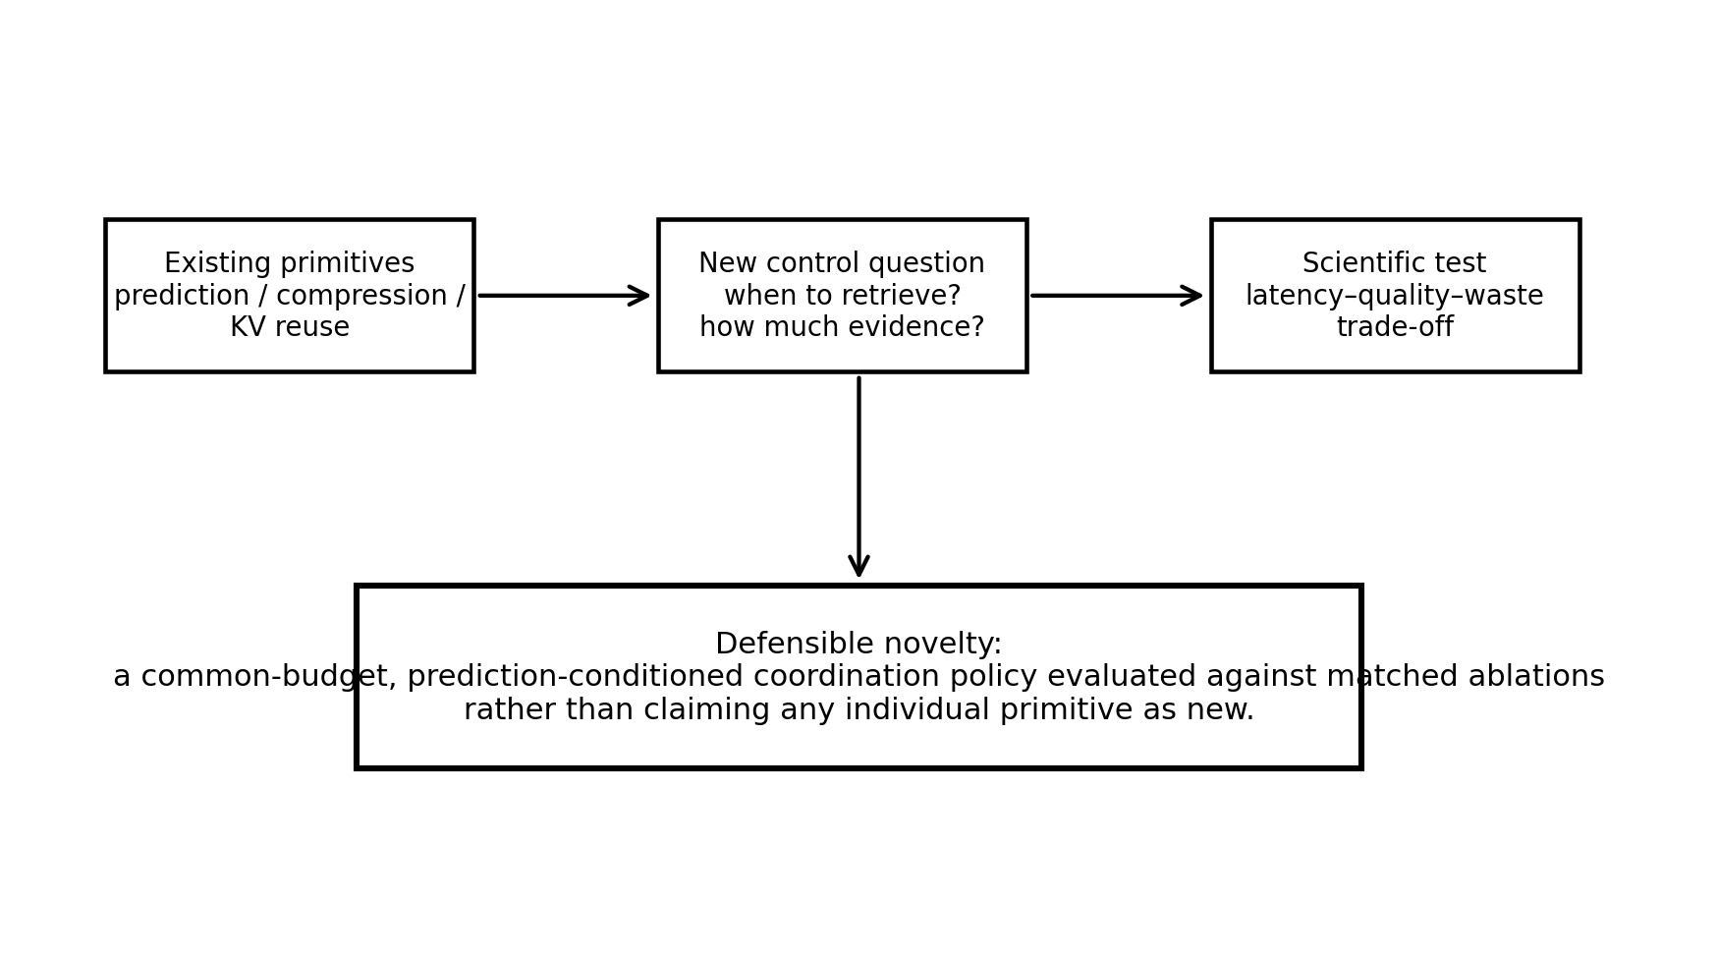
Figure 5. Scientific novelty is framed as a coordination/control question, not primitive invention.

9. Core novelty — scientific novelty, not model branding
The scientific novelty is the formulation and empirical test of RAG latency optimization as a coupled resource-allocation problem. Prior work demonstrates strong solutions to individual decisions: when to retrieve, how to compress, and how to reuse KV states. This proposal asks whether these decisions should share a common state and budget.
Formal view:
Given state s_t = {retrieval probability, generation position, evidence utility, context length, cache state, measured stage latencies}, choose action a_t = {retrieve/skip, prefetch timing, evidence budget, cache use} to minimize expected latency subject to an answer-quality constraint.
The contribution is therefore a scientific hypothesis about coordination: independent optimizers may be locally optimal for their own objective but globally suboptimal once their overheads interact. This can be tested without claiming that any component is individually new.

10. Main research contribution
ID | Contribution | What it demonstrates | Type
C1 | A prediction-conditioned resource-allocation formulation | Defines retrieval and evidence budget as coupled decisions. | Scientific
C2 | A lightweight local controller | Uses model-internal signals and measured latency rather than an external API-only assumption. | Algorithmic
C3 | A matched causal benchmark | Compares standard, prediction-only, compression-only, cache-only and coordinated systems under identical conditions. | Experimental
C4 | A failure taxonomy | Separates false-positive retrieval, over-compression, controller overhead, cache-transfer overhead and generation-dominated cases. | Analytical
C5 | A local latency–quality frontier | Reports P50/P95/P99, TTFT, E2E, quality and memory on the same hardware. | Systems/empirical
C6 | Optional cache extension | Tests whether compressed-context reuse creates additional benefit after the controller is validated. | Extension

11. Related applications
- Private enterprise knowledge assistants where GPU resources are limited and retrieval latency is visible to users.
- Local/offline RAG for privacy-sensitive documents where external API inference is undesirable.
- Technical support and maintenance manuals with long retrieved contexts.
- Legal, financial and scientific document assistants where evidence preservation is important.
- On-device or workstation research assistants where 3B–8B open models are preferred over cloud APIs.
- Later multimodal document assistants, provided a visual retriever such as ColPali/ColQwen is added and the core controller is revalidated.

12. Proposed model framework
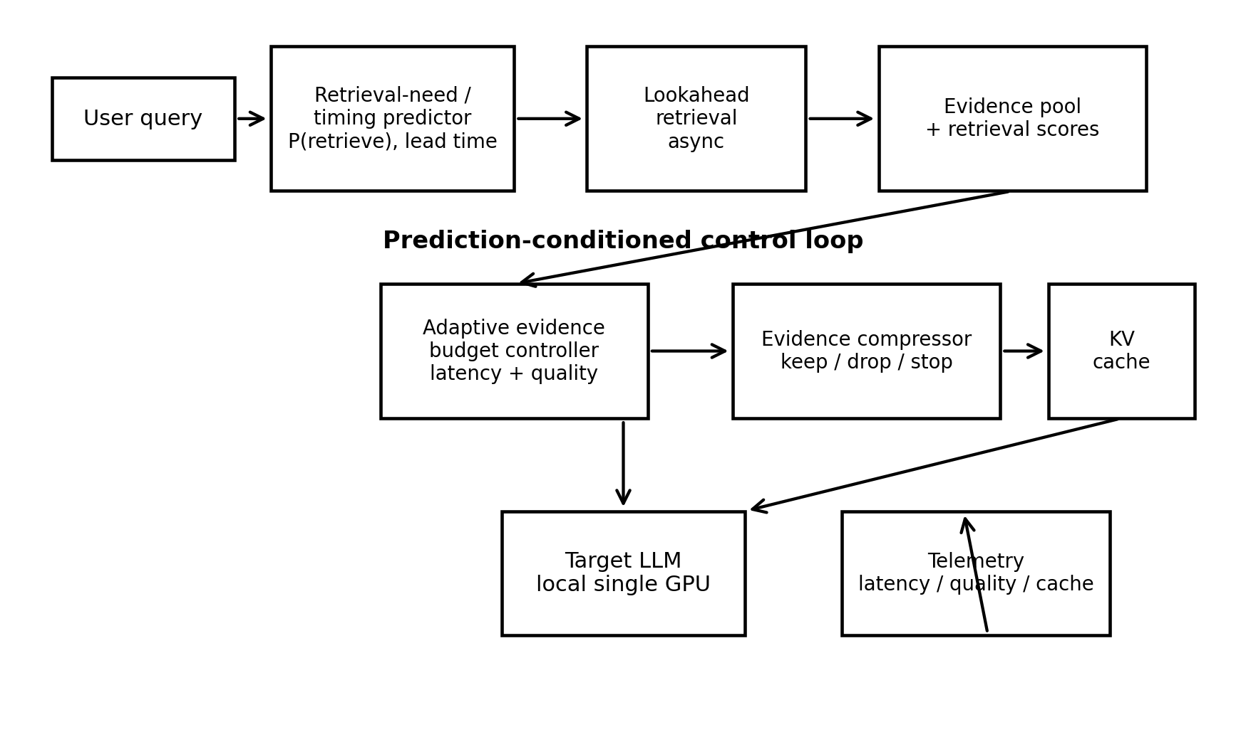
Figure 2. PACER proposed runtime framework.
Core modules:
- Retrieval-need/timing predictor: estimates P(retrieve | generation state) and an expected useful lead time.
- Lookahead retrieval executor: issues a retrieval request only when the controller's expected benefit exceeds the measured overhead.
- Evidence utility estimator: scores retrieved evidence using an ECoRAG/ACC-RAG-inspired signal.
- Adaptive evidence-budget controller: maps evidence utility, prediction confidence, current context length and latency budget to a retained evidence budget.
- Local LLM executor: generates using the selected evidence.
- Optional compressed-context KV cache: stores reusable representations only when the cache state and transfer cost make reuse profitable.
- Telemetry: logs all stage times and quality outcomes so that every claimed saving is a net end-to-end result.
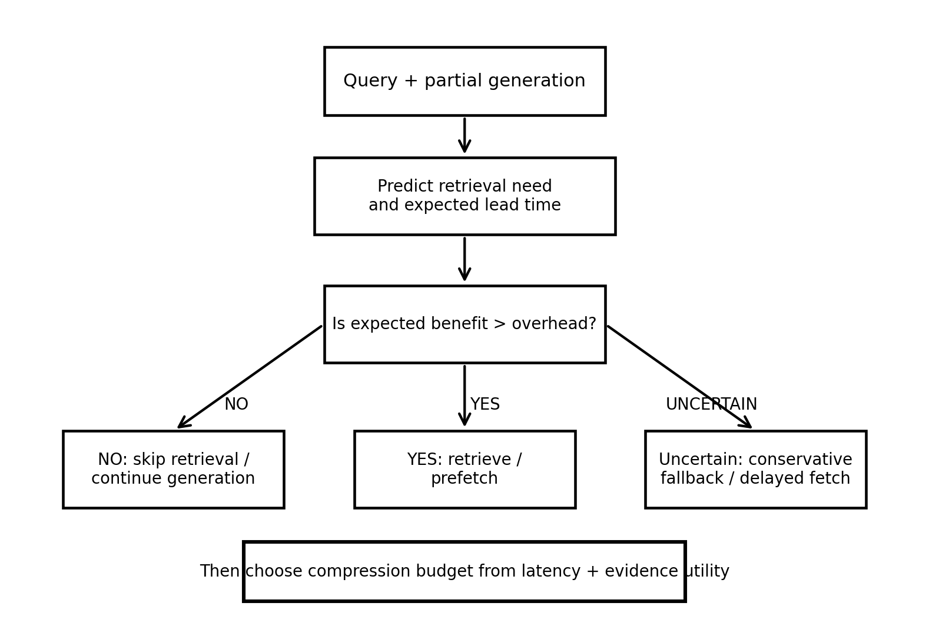
Figure 3. The critical gating mechanism that prevents the predictor from merely becoming an independent prefetch module.

13. Research contribution that can outperform prior work
The proposal must not promise that PACER will beat every published paper. That would be scientifically unsafe because those papers optimize different hardware and workloads. Instead, 'beat others' is defined as winning a controlled local comparison under the same budget.
System | Strength | Primary cost/risk | Controlled comparison
Standard RAG | Full retrieval + full context | No controller overhead | Reference quality / latency
Predictive retrieval | Predictive timing | May waste prefetch | Test net benefit
Adaptive compression | Smaller context | Compression/controller cost | Test token and E2E savings
KV reuse | Less prefill | Cache transfer / recomputation | Test TTFT
PACER core | Prediction + adaptive evidence budget | Coordination overhead | Target: lower E2E at non-inferior quality
PACER + cache | Core + compressed-context reuse | Cache management overhead | Target: improved Pareto frontier

A scientifically meaningful win is defined as a statistically supported improvement on the same benchmark split and hardware, not a comparison against an incompatible headline number from another paper.

14. Model novelty
The architectural novelty is a shared controller state. Existing modules are retained where they are already strong; PACER adds a coordination layer above them.
- Shared state: retrieval confidence + evidence utility + measured stage latency + context length + cache state.
- Shared action space: retrieve/skip, retrieve-now/retrieve-ahead, retain-more/retain-less, cache/recompute.
- Shared objective: minimize end-to-end latency subject to a non-inferior answer-quality constraint.
- Fallback: when prediction confidence is low or expected savings are negative, the controller falls back to standard retrieval rather than forcing speculation.
The architecture should therefore be implemented as a controller around established components, not as a monolithic end-to-end model whose internal decisions cannot be attributed.

15. Hypotheses and falsification criteria
Hypothesis | Expected result | Falsification
H1 | Prediction-conditioned budgeting lowers E2E latency versus prediction-only and compression-only systems. | False if overhead eliminates the gain across held-out workloads.
H2 | Joint control lowers unnecessary retrieval/compression work without reducing answer quality. | False if resource savings require a quality loss or do not appear in matched traces.
H3 | Benefits depend on workload state, not one global fixed compression ratio. | False if a fixed policy is statistically indistinguishable across complexity strata.
H4 | Cache reuse adds a second-stage gain only when reuse probability and transfer cost justify it. | False if cache overhead exceeds saved prefill on the target hardware.

16. Dataset and benchmark plan
The core study should remain text-first because the primary scientific question concerns retrieval timing, evidence compression and local LLM prefill. The multimodal datasets below are an extension/secondary track for testing whether the same controller generalizes when evidence is visual.
Dataset | Type | Size | Access | Priority | How applied | Link
HotpotQA | Multi-hop open-domain QA | ~113k questions | Public | High | Core multi-hop retrieval/compression; evidence attribution | https://hotpotqa.github.io/
2WikiMultihopQA | Multi-hop QA with reasoning paths | 192,606 examples | Public | High | Multi-hop evidence selection and controller stability | https://github.com/Alab-NII/2wikimultihop
Natural Questions | Real Google user questions + Wikipedia | 307,372 train; 7,830 dev; 7,842 test | Public | High | Broad open-domain RAG and long evidence pages | https://ai.google.com/research/NaturalQuestions/download
TriviaQA | Reading comprehension with evidence documents | 95k QA pairs; >650k QA-evidence triples | Public | High | Diverse evidence and compositional questions | http://nlp.cs.washington.edu/triviaqa/
LongBench | Bilingual long-context benchmark | 21 datasets; 6 task categories | Public | High | Long-context stress testing; use selected English multi-doc subsets | https://aclanthology.org/2024.acl-long.172/

17. Multimodal dataset extension
Dataset | Modality | Size | Access | Application | Public link
DocVQA | Document images / text / layout | 50K questions; 12K+ images | Public | Primary visual extension; evidence compression over pages/regions | https://www.docvqa.org/datasets/docvqa
MP-DocVQA | Multi-page scanned industry documents | 46,436 questions; 5,929 documents | Public | Tests multi-page evidence selection and page-level budgeting | https://huggingface.co/datasets/rubentito/mp-docvqa
InfographicVQA | Infographics with text + graphics | 30,035 questions; 5,485 images | Public | Tests visual + textual evidence selection | https://site.docvqa.org/datasets/infographicvqa
ChartQA | Charts + logical/arithmetic reasoning | 32.7K questions; 9.6K human-written + 23.1K generated | Public | Tests whether evidence budgeting preserves numerical/chart evidence | https://arxiv.org/abs/2203.10244
ChartQAPro | Real-world diverse charts | 1,341 charts; 1,948 questions | Public | Harder robustness check; unanswerable/conversational/hypothetical cases | https://arxiv.org/abs/2504.05506
SlideVQA | Multi-image slide-deck QA | 2.6K+ decks; 52K+ slide images; 14.5K questions | Public | Tests cross-page retrieval and evidence budgeting | https://ojs.aaai.org/index.php/AAAI/article/view/26598
MMLongBench-Doc | Long-context document understanding with visualizations | Public benchmark; multi-page PDFs; 33% cross-page questions | Public research use | Stress test for multi-page evidence aggregation; license is non-commercial | https://github.com/mayubo2333/MMLongBench-Doc
ViDoRe | Visual document retrieval benchmark | Multiple public subsets; current V3 collection includes domain-specific sets | Public | Evaluate visual retriever latency/recall before multimodal generation | https://huggingface.co/collections/vidore/vidore-benchmark

Dataset-size note: sizes are reported as published or on the cited dataset pages and may differ by release/version. For the final paper, the exact downloaded revision, split counts, storage size and license should be recorded in the experiment manifest.

18. Private / authorized datasets
Private source | Content | Size | Access | How applied
Institutional documents | Internal reports, manuals, policies, technical documents | Size unknown until authorized corpus is received | Private / permission required | Evaluate robustness on realistic non-public evidence; never publish raw documents without authorization.
Enterprise knowledge base | Internal support/operations documents | Size to be measured | Private / permission required | Test freshness, repeated queries, cache reuse and document churn.
Self-collected restricted corpus | Researcher-collected PDFs under usage restrictions | Target 1k–10k documents if feasible | Restricted by source licenses | Stress-test domain shift while retaining a legally usable evaluation subset.

No private corpus is assumed to be already accessible. It should be included only after written authorization and license review. The public benchmark results remain the primary reproducibility layer.

19. Experimental design and ablations
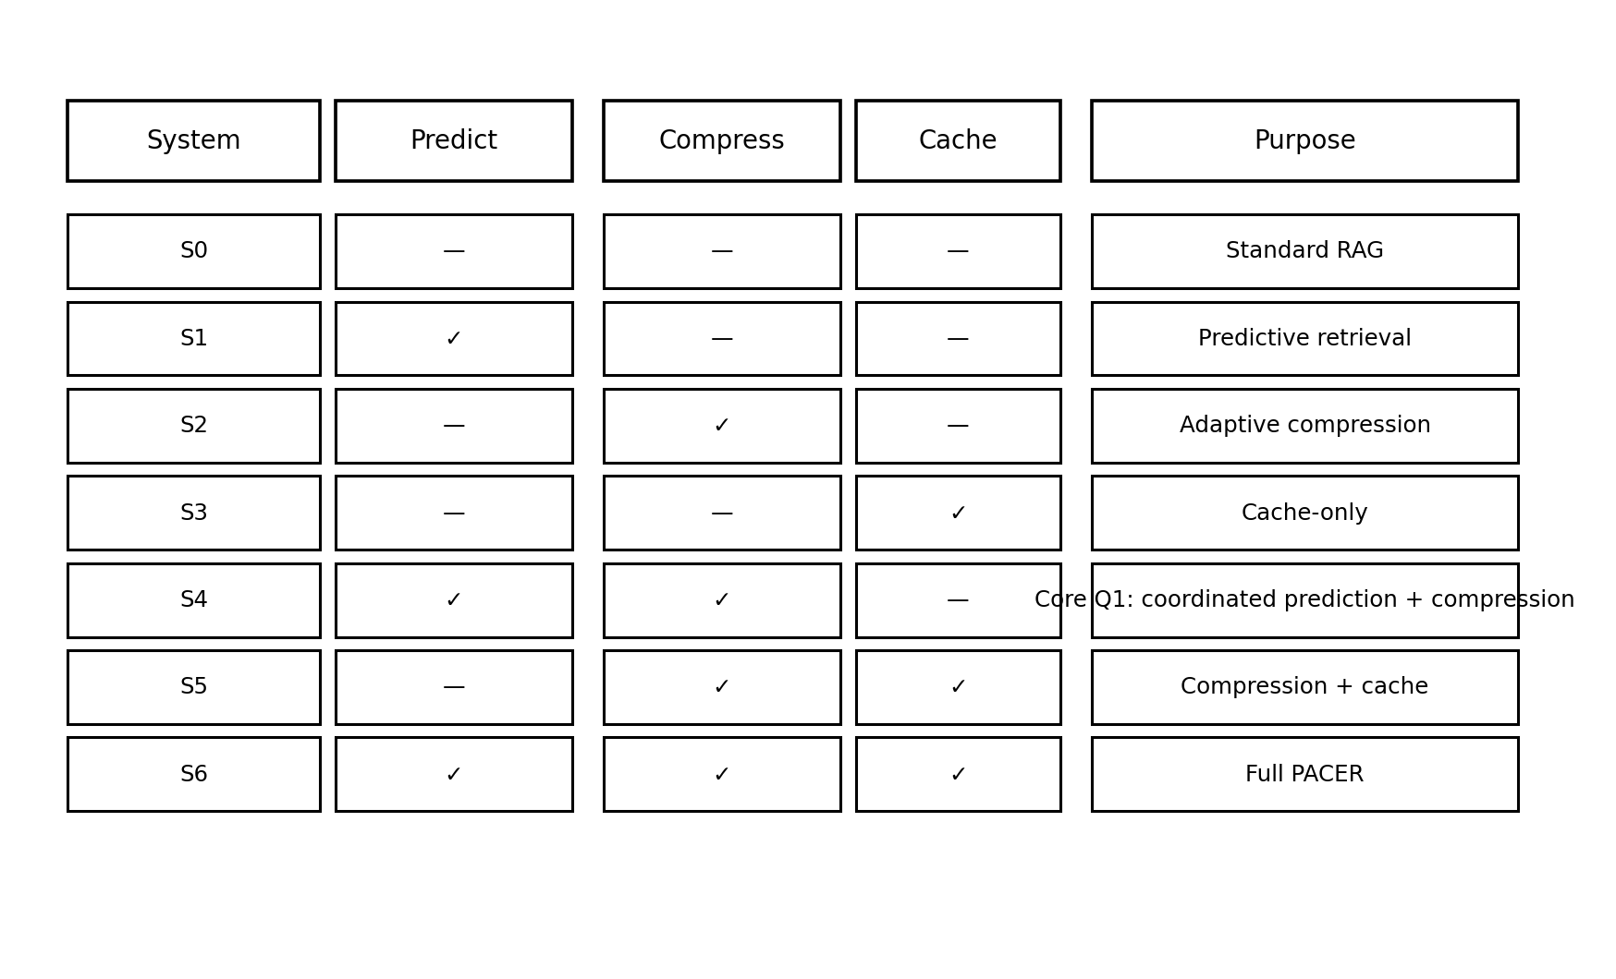
Figure 4. Recommended ablation matrix.
ID | Components | Purpose
S0 | Standard RAG | Reference
S1 | Prediction + lookahead retrieval | Predictive timing effect
S2 | Adaptive compression | Evidence-budget effect
S3 | Selective KV reuse | Cache effect
S4 | Prediction + adaptive compression | Primary RQ1 test
S5 | Adaptive compression + cache | Compression/cache interaction
S6 | Prediction + adaptive compression + cache | Full PACER extension

The primary scientific comparison is S4 against S0, S1 and S2. S6 should not be used to obscure a weak S4 result.

20. Metrics
Dimension | Measures | Priority
Latency | TTFT, E2E, P50/P95/P99, TPOT | Primary
Retrieval | retrieval calls, prefetch hit, false-positive/wasted prefetch, retrieval latency | Primary
Compression | compression time, input/output tokens, compression ratio, controller overhead | Primary
Cache | hit rate, recomputation ratio, transfer time, memory footprint | Secondary
Quality | EM, token F1, ROUGE-L where appropriate; task-specific exact metrics for visual datasets | Primary
Efficiency | GPU memory, peak VRAM, CPU RAM, storage I/O, tokens/sec | Primary
Robustness | performance by query complexity, evidence count, context length and retrieval latency | Primary

21. Statistical analysis
- Use identical query IDs across systems so latency and quality are paired observations.
- Report median and tail latency, not only mean speedup.
- Use paired bootstrap confidence intervals for latency differences.
- Use paired Wilcoxon signed-rank tests for per-query quality comparisons where appropriate.
- Apply Holm–Bonferroni correction for multiple pairwise comparisons.
- Report effect sizes and confidence intervals, not only p-values.
- Plot accuracy/quality versus TTFT and E2E Pareto frontiers.
- Stratify results by query difficulty and evidence count to expose when coordination helps or hurts.

22. Feasibility and implementation constraints
A 24-GB-class GPU is a reasonable target for the core experiment, but the proposal should not assume that all published implementations can coexist unchanged. The predictor, compressor and cache must be profiled separately before co-residency.
- Start with one 7B–8B model and one retriever; add a second model only after the harness is stable.
- Prefer training-free or lightweight modules first. Do not reproduce large multi-GPU fine-tuning recipes and call them equivalent local replications.
- Use 4-bit quantization or parameter-efficient tuning only when the baseline's scientific behavior remains comparable.
- Pin CUDA, driver, inference engine, retriever and storage versions.
- Warm up the GPU and report whether cache/warm-start effects are included.
- Measure controller overhead independently.
- Keep a strict distinction between offline preprocessing time and online user-visible latency.

23. Risks and mitigation
Risk | Why it matters | Mitigation
Novelty overclaim | A newer paper may overlap a claimed gap. | Use a living related-work table and phrase novelty as the coordination experiment.
Predictor overhead | Prediction costs more than it saves. | Use expected-benefit gating and report net E2E latency.
Compression overhead | Scoring/selection cancels prefill savings. | Benchmark compressor alone and use a latency budget.
Low predictor accuracy | Prediction cannot safely gate retrieval. | Fallback to standard retrieval below a calibrated confidence threshold.
Cache complexity | Cache extension becomes the whole project. | Treat caching as Phase 2; publish the core controller experiment independently.
Dataset leakage | Training traces overlap evaluation queries. | Use disjoint query IDs and corpus splits; document every split.
Hardware variance | Small timing differences disappear across machines. | Report exact hardware/software and repeated runs.
Multimodal scope creep | Visual datasets require a different retriever/model stack. | Keep multimodal work as a secondary extension.

24. Actual novelty audit — paper by paper
Paper | Overlap | What we must NOT claim | Ref.
RAGCache | High overlap in caching infrastructure | Not novel to propose KV caching; novel only if coordination with evidence-budget control is shown. | [1]
TurboRAG | High overlap in offline KV reuse | Do not claim offline KV precomputation as new. | [2]
CacheBlend | High overlap in selective recomputation | Do not claim selective KV recomputation as new. | [3]
SpecCache | High overlap in predictive KV selection | Do not claim learned/speculative KV selection as new. | [4]
CacheTune | High overlap in adaptive hardware-aware cache reuse | Do not claim adaptive cache ratio as new. | [5]
FusionRAG | High overlap in cross-chunk cache fusion | Do not claim context-aware cache fusion as new. | [6]
PCR | High overlap in cache prefetch/I-O overlap | Do not claim cache prefetching as new. | [7]
CoinRAG | High overlap in fine-grained/nugget KV reuse | Do not claim semantic nugget caching as new. | [8]
Predictive Prefetching | Direct overlap in learned retrieval timing | Do not claim retrieval-need prediction as new. | [9]
TeleRAG | Direct overlap in lookahead retrieval + local RTX 4090 validation | Do not claim single-GPU lookahead as new. | [10]
HedraRAG | Partial overlap in coordinated RAG serving | Different emphasis: local, single-query prediction/evidence budgeting. | [11]
RAGO | Partial overlap in workload-aware RAG optimization | Use as systems motivation; local budget controller is narrower. | [12]
VoiceAgentRAG | Partial overlap in background predictive retrieval | Different task setting; local text-QA latency control remains a separate evaluation. | [13]
REFRAG | Partial overlap in context compression | Do not claim architectural compression generally; use as prior art. | [14]
ECoRAG | Direct overlap in evidence-aware compression | Do not claim evidentiality-based compression as new. | [15]
ACC-RAG | Direct overlap in adaptive compression | Do not claim query-adaptive compression as new. | [16]
CORE-RAG | Partial/direct overlap in performance-driven compression | Do not claim task-performance-driven compression as new. | [17]
HPC-ColPali | Adjacent visual retrieval compression | Not a core text-RAG novelty baseline; use in extension. | [18]
DocPC | Adjacent visual document-level page selection | Not a core text-RAG novelty baseline; use in extension. | [19]
PULSAR | Adjacent visual retrieval pooling/quantization | Not a core text-RAG novelty baseline; use in extension. | [20]

Bottom line of the audit: the safest novelty statement is not 'no one has combined these techniques.' It is: 'the proposal studies a prediction-conditioned, latency-budgeted coordination policy across retrieval triggering and evidence allocation, using matched ablations on the same local hardware, with an optional cache extension.' The novelty becomes empirical and mechanistic rather than a simple absence claim.

25. Positioning matrix
System | Signal | Systems mechanism | Adaptive context | Key missing/target | Proposed positioning
Predictive Prefetching | Prediction | Retrieval timing | — | No adaptive evidence budget | Large/specified local experiments
TeleRAG | Lookahead | Systems overlap | GPU-memory aware | — | Yes, RTX 4090 artifact
ECoRAG | Evidence score | — | Adaptive evidence filtering | No learned timing coupling | RAG QA
ACC-RAG | Query complexity | — | Adaptive compression | Controller overhead | RAG QA
CacheBlend | — | KV reuse | Selective recomputation | — | Open-source/local reproduction
CacheTune | — | KV reuse | Hardware-aware cache ratio | — | Long-context serving
FusionRAG | Similarity/query signals | KV reuse | — | Offline context fusion | Systems
CoinRAG | Query relevance | Nugget KV reuse | Fine-grained context | Model-specific adaptation | LongBench
PACER | Prediction + evidence utility | Optional cache reuse | Adaptive budget | Joint latency-quality controller | Single-GPU controlled study

26. Implementation workflow
- Phase 0: freeze hardware, software, model, retriever and datasets.
- Phase 1: build standard RAG timing/quality harness.
- Phase 2: reproduce one predictive retrieval baseline and one adaptive compression baseline.
- Phase 3: collect retrieval-need traces without touching the held-out evaluation set.
- Phase 4: train/calibrate the lightweight predictor.
- Phase 5: implement prediction-conditioned evidence budgeting.
- Phase 6: run S0–S4 and perform statistical analysis.
- Phase 7: only if S4 is stable, implement compressed-context KV reuse and run S5–S6.
- Phase 8: optional multimodal extension with DocVQA/MP-DocVQA/ViDoRe.

27. End-to-end evaluation protocol
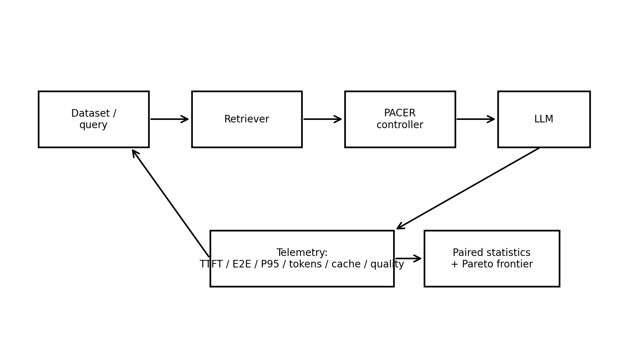
Figure 6. Reproducible evaluation loop.

28. Expected outcomes
Three outcomes are scientifically acceptable. Outcome A: PACER improves the latency–quality frontier, supporting the coordination hypothesis. Outcome B: PACER matches the best single technique, showing that coordination is unnecessary under the tested local regime. Outcome C: PACER loses because controller/compression overhead dominates, identifying a boundary condition for adaptive RAG optimization. The proposal is successful if it can distinguish these cases rigorously.

29. Reproducibility requirements
- Release code for the controller, baselines and measurement harness.
- Record exact model revisions and tokenizer versions.
- Release configuration files and seeds.
- Release query IDs and derived benchmark subsets where licenses permit.
- Release latency logs with stage-level timings.
- Report GPU model, VRAM, CUDA, driver, inference engine, FAISS/vector database and storage medium.
- Record dataset version/date and exact downloaded size.
- Separate offline preprocessing cost from online inference cost.

30. Limitations
- The project is not a universal RAG serving system and does not target multi-GPU throughput optimization.
- Results on one 24-GB-class GPU may not transfer directly to data-center accelerators.
- A controller trained on one model family may not transfer to another without calibration.
- Multimodal extension changes the retrieval stack and should be reported separately.
- If the optional cache module requires extensive kernel engineering, it should remain a follow-on contribution rather than compromise the core study.

31. Conclusion
The revised proposal is intentionally more conservative than the original PACER draft. The literature already establishes predictive retrieval, lookahead retrieval, adaptive compression, selective KV reuse, cache prefetching, and visual-document compression as active and increasingly mature research directions. The defensible scientific opportunity is to test whether these decisions should be coordinated under one local latency-quality budget, with explicit accounting for controller overhead and failure cases.
The project should therefore be presented as a hypothesis-driven systems/NLP study of prediction-conditioned resource allocation. The optional cache layer strengthens the system contribution, but the primary scientific result should stand independently as S4: prediction-conditioned adaptive evidence budgeting.

32. References
[1] Jin, Chao; Zhang, Zili; Jiang, Xuanlin; Liu, Fangyue; Liu, Xin; Liu, Xuanzhe; Jin, Xin. “RAGCache: Efficient Knowledge Caching for Retrieval-Augmented Generation.” arXiv:2404.12457, 2024. https://arxiv.org/abs/2404.12457
[2] Lu, Songshuo; Wang, Hua; Rong, Yutian; Chen, Zhi; Tang, Yaohua. “TurboRAG: Accelerating Retrieval-Augmented Generation with Precomputed KV Caches for Chunked Text.” EMNLP 2025. https://aclanthology.org/2025.emnlp-main.334/
[3] Yao, Jiayi; Li, Hanchen; Liu, Yuhan; Ray, Siddhant; Cheng, Yihua; Zhang, Qizheng; Du, Kuntai; Lu, Shan; Jiang, Junchen. “CacheBlend: Fast Large Language Model Serving for RAG with Cached Knowledge Fusion.” EuroSys 2025. https://www.microsoft.com/en-us/research/publication/you-only-prefill-once-combining-cached-knowledge-for-large-language-model-serving-with-cacheblend/
[4] Wen, Zijian; Zhang, Tao; Chen, Shuangwu; Ye, Shenghao; Guo, Yu; Chen, Qirui; Shuai, Jingxian; Hou, Yunpeng; He, Huasen; et al. “SpecCache: Speculative KV Cache Reuse for Efficient RAG Serving.” ACL 2026. https://aclanthology.org/2026.acl-long.859/
[5] Li, Fei; Liu, Song; Liu, Yan; Cui, Jinhua; Nie, Shiqiang; Wang, Jinyu; Wu, Weiguo. “Adaptive KV Cache Reuse for Fast Long-Context LLM Serving.” arXiv:2605.24022, 2026. https://arxiv.org/abs/2605.24022
[6] Wang, Jiahao; Xie, Weiyu; Zhang, Mingxing; Zhang, Boxing; Dong, Jianwei; Zhu, Yuening; Lin, Chen; Tang, Jinqi; Han, Yaochen; Ai, Zhiyuan; Chen, Xianglin; Wu, Yongwei; Jiang, Congfeng. “From Prefix Cache to Fusion RAG Cache: Accelerating LLM Inference in Retrieval-Augmented Generation.” SIGMOD 2026; arXiv:2601.12904. https://arxiv.org/abs/2601.12904
[7] Wang, Wenfeng; Hou, Xiaofeng; Tang, Peng; Zhou, Hengyi; Wang, Jing; Wang, Xinkai; Li, Chao; Guo, Minyi. “PCR: A Prefetch-Enhanced Cache Reuse System for Low-Latency RAG Serving.” arXiv:2603.23049, 2026. https://arxiv.org/abs/2603.23049
[8] Kim, Gyuwan; Park, Cheoneum; Yang, Tao. “CoinRAG: Contextualized Information Nugget KV Cache Reuse for Long-Context RAG.” arXiv:2608.07458, 2026. https://arxiv.org/abs/2608.07458
[9] Zhang, Wuyang; Pei, Shichao. “Predictive Prefetching for Retrieval-Augmented Generation.” ICML 2026, PMLR 306. https://proceedings.mlr.press/v306/zhang26eu.html
[10] Lin, Chien-Yu; Kamahori, Keisuke; Liu, Yiyu; Shi, Xiaoxiang; Kashyap, Madhav; Gu, Yile; Shao, Rulin; Ye, Zihao; Zhu, Kan; Kadekodi, Rohan; et al. “TeleRAG: Efficient Retrieval-Augmented Generation Inference with Lookahead Retrieval.” MLSys 2026; arXiv:2502.20969. https://arxiv.org/abs/2502.20969
[11] Hu, Zhengding; Murthy, Vibha; Pan, Zaifeng; Li, Wanlu; Fang, Xiaoyi; Ding, Yufei; Wang, Yuke. “HedraRAG: Coordinating LLM Generation and Database Retrieval in Heterogeneous RAG Serving.” arXiv:2507.09138, 2025. https://arxiv.org/abs/2507.09138
[12] Jiang, Wenqi; Subramanian, Suvinay; Graves, Cat; Alonso, Gustavo; Yazdanbakhsh, Amir; Dadu, Vidushi. “RAGO: Systematic Performance Optimization for Retrieval-Augmented Generation Serving.” arXiv:2503.14649, 2025. https://arxiv.org/abs/2503.14649
[13] Qiu, Jielin; Zhang, Jianguo; Chen, Zixiang; Yang, Liangwei; Zhu, Ming; Tan, Juntao; et al. “VoiceAgentRAG: Solving the RAG Latency Bottleneck in Real-Time Voice Agents Using Dual-Agent Architectures.” arXiv:2603.02206, 2026. https://arxiv.org/abs/2603.02206
[14] Lin, Xiaoqiang; Ghosh, Aritra; Low, Bryan Kian Hsiang; Shrivastava, Anshumali; Mohan, Vijai. “REFRAG: Rethinking RAG based Decoding.” arXiv:2509.01092, 2025. https://arxiv.org/abs/2509.01092
[15] Jeong, Yeonseok; Kim, Jinsu; Lee, Dohyeon; Hwang, Seung-won. “ECoRAG: Evidentiality-guided Compression for Long Context RAG.” Findings of ACL 2025, 26607–26628. https://aclanthology.org/2025.findings-acl.1365/
[16] Guo, Shuyu; Zhang, Shuo; Ren, Zhaochun. “Enhancing RAG Efficiency with Adaptive Context Compression.” Findings of EMNLP 2025, 24061–24076. https://aclanthology.org/2025.findings-emnlp.1307/
[17] Cui, Ziqiang; Weng, Yunpeng; Tang, Xing; Liu, Peiyang; Li, Shiwei; He, Bowei; Chen, Jiamin; Zhang, Yansen; He, Xiuqiang; Zhang, Rui; Ma, Chen. “Less Is More: Elevating RAG via Performance-Driven Context Compression.” ICML 2026, PMLR 306:22030–22046. https://proceedings.mlr.press/v306/cui26i.html
[18] Bach, Duong. “Hierarchical Patch Compression for ColPali: Efficient Multi-Vector Document Retrieval with Dynamic Pruning and Quantization.” arXiv:2506.21601, 2025. https://arxiv.org/abs/2506.21601
[19] You, Chengsong; Zhou, Junwei; Du, Nan. “DocPC: Document-Level Visual Retrieval via Representative Page Composition.” arXiv:2608.25434, 2026. https://arxiv.org/abs/2608.25434
[20] “PULSAR.” arXiv:2608.28572, 2026. https://arxiv.org/abs/2608.28572
[21] Sharma. “Retrieval-Augmented Generation survey.” arXiv:2506.00054, 2025. https://arxiv.org/abs/2506.00054
[22] Singh, Ehtesham, Kumar, Talaei Khoei, Vasilakos. “Agentic RAG: A Survey on Agentic Retrieval-Augmented Generation.” arXiv:2501.09136, 2025/2026. https://arxiv.org/abs/2501.09136
[23] Yang, Zhilin; Qi, Yiming; Zhang, Saizheng; et al. “HotpotQA: A Dataset for Diverse, Explainable Multi-hop Question Answering.” EMNLP 2018. https://hotpotqa.github.io/
[24] Ho, Xanh; Nguyen, Anh-Khoa Duong; Sugawara, Saku; Aizawa, Akiko. “Constructing A Multi-hop QA Dataset for Comprehensive Evaluation of Reasoning Steps.” COLING 2020. https://aclanthology.org/2020.coling-main.580/
[25] Kwiatkowski, Tom; Palomaki, Jennimaria; Redfield, Olivia; et al. “Natural Questions: A Benchmark for Question Answering Research.” TACL 2019. https://ai.google.com/research/NaturalQuestions/download
[26] Joshi, Mandar; Choi, Eunsol; Weld, Daniel; Zettlemoyer, Luke. “TriviaQA: A Large Scale Distantly Supervised Challenge Dataset for Reading Comprehension.” ACL 2017. https://aclanthology.org/P17-1147/
[27] Bai, Yushi; Lv, Xin; Zhang, Jiajie; et al. “LongBench: A Bilingual, Multitask Benchmark for Long Context Understanding.” ACL 2024. https://aclanthology.org/2024.acl-long.172/
[28] Mathew, Minesh; Karatzas, Dimosthenis; Jawahar, C. V. “DocVQA: A Dataset for VQA on Document Images.” WACV 2021. https://www.docvqa.org/datasets/docvqa
[29] Tito, Ruben; Mathew, Minesh; Jawahar, C. V.; Valveny, Ernest; Karatzas, Dimosthenis. “Multi-Page Document Visual Question Answering (MP-DocVQA).” 2022 dataset/benchmark. https://huggingface.co/datasets/rubentito/mp-docvqa
[30] Mathew, Minesh; Bagal, Viraj; Pérez Tito, Rubèn; Karatzas, Dimosthenis; Valveny, Ernest; Jawahar, C. V. “InfographicVQA.” arXiv:2104.12756, 2021. https://arxiv.org/abs/2104.12756
[31] Masry, Ahmed; Long, Do Xuan; Tan, Jia Qing; Joty, Shafiq; Hoque, Enamul. “ChartQA: A Benchmark for Question Answering about Charts with Visual and Logical Reasoning.” Findings of ACL 2022. https://arxiv.org/abs/2203.10244
[32] Tanaka, Ryota; Nishida, Kyosuke; Nishida, Kosuke; Hasegawa, Taku; Saito, Itsumi; Saito, Kuniko. “SlideVQA: A Dataset for Document Visual Question Answering on Multiple Images.” AAAI 2023. https://ojs.aaai.org/index.php/AAAI/article/view/26598
[33] Ma, Yubo; Zang, Yuhang; Chen, Liangyu; et al. “MMLongBench-Doc: Benchmarking Long-context Document Understanding with Visualizations.” arXiv:2407.01523, 2024. https://arxiv.org/abs/2407.01523
[34] ViDoRe Benchmark. Visual document retrieval benchmark collection and evaluation resources. https://huggingface.co/collections/vidore/vidore-benchmark
[35] Masry, Ahmed; Islam, Mohammed Saidul; Ahmed, Mahir; et al. “ChartQAPro: A More Diverse and Challenging Benchmark for Chart Question Answering.” arXiv:2504.05506, 2025. https://arxiv.org/abs/2504.05506

Source and verification note
This revision was grounded first in the supplied research_gap_latency based.md and PACER_Project_Proposal_v2.docx, then cross-checked against official publisher pages, ACL Anthology, PMLR, arXiv records, and official dataset pages where available. Where the supplied research-gap document described a paper's limitation or result, that description was retained as an input to the analysis but not automatically treated as a novelty claim. Newer 2026 work was used specifically to remove or soften claims that were no longer defensible.

